Database Assignment 1

Note : Use Emp, dept and salgrade table

1.To list all records with sal > 2000 and comm>200

mysql> select * from emp where sal>2000 and comm>200;



2.To list all record with job=’Clerk’ or sal>2000

mysql> select * from emp where job='Clerk' or sal>2000;

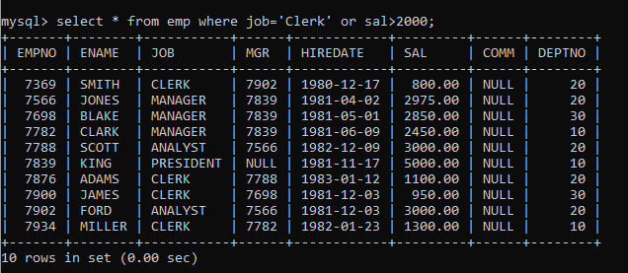

3. To list all the record with sal=1250 or 1100 or 2850

my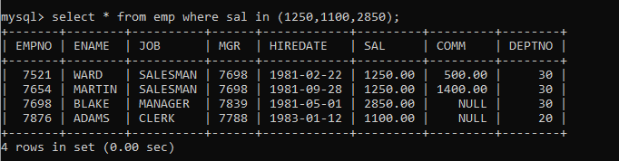sql> select * from emp where sal in (1250,1100,2850);

4. To list all employees with sal>1250 and <2850

mysql> select * from emp where sal between 1250 and 2850;

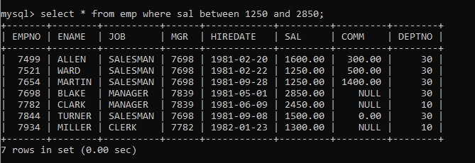

5. To list all employees with name ends with AS

mysql> select * from emp where ename like '%AS';



6. To list all employees with job starts with C and ends with K

mysql> select * from emp where ename like 'C%K';

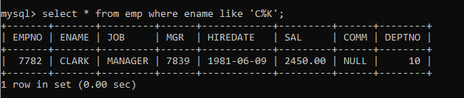

7. To list all employees with job contains L at third position and

M at third last position

mysql> select * from emp where job like '__L%M__';

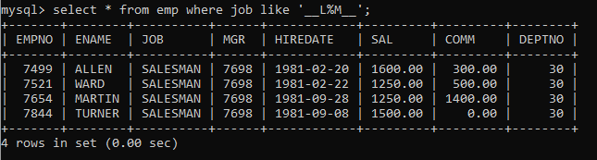

8. To list all the record with sal not equal to 1250 or 1100 or 2850

mysql> select * from emp where sal not in (1250,1100,2850);

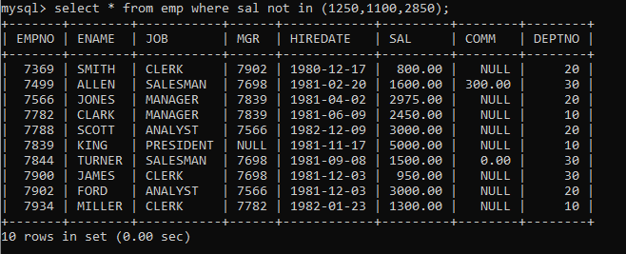

9. To list all employees with salnot >1250 and <2850

mysql> select * from emp where sal not between 1250 and 2850;

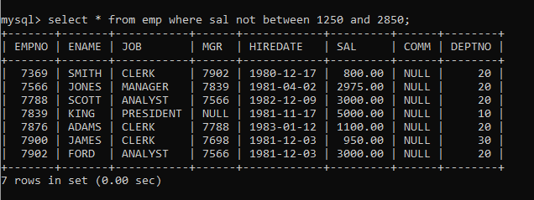

10. To list all employees with job starts with C , E at 3rd position and ends with K

mysql> select * from emp where job like 'C_E%K';

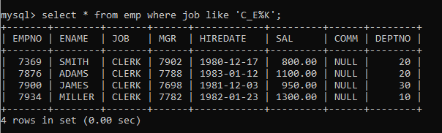

11. To list all rows with comm is null

mysql> select * from emp where comm is null;

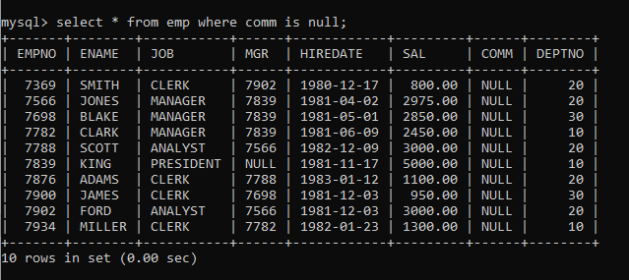

12. To list all employees with sal is null and name starts with ‘S’

mysql> select * from emp where sal is null and ename like 'S%';



13. To list all employees with job contains 5 characters

mysql> select * from emp where job like '_____';

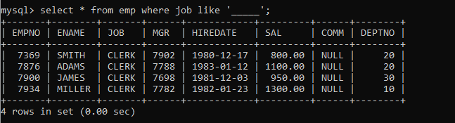

14. To list all employees with name contain ‘A’ at 1 position and job

Contains 5 characters

mysql> select * from emp where ename like 'A%' and job like '_____';

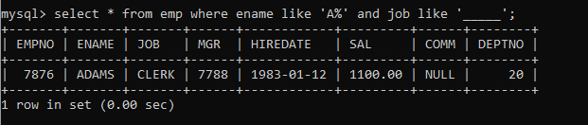

Q2. Solve the following

1. Retrieve the details (Name, Salary and dept no) of the emp who are working in

department code 20, 30 and 40.

mysql> select ename,sal,deptno from emp where deptno in (20,30,40);

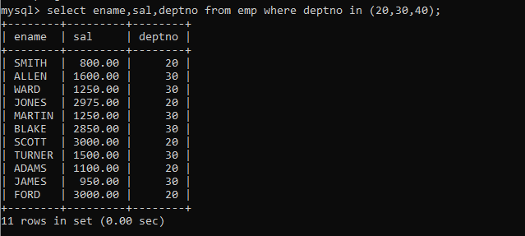

2. Display the total salary of all employees . Total salary will be calculated as

sal+comm+sal*0.10

mysql> select ename , sal , sal+ifnull(comm,0)+sal*0.10 TotalSalary from emp;

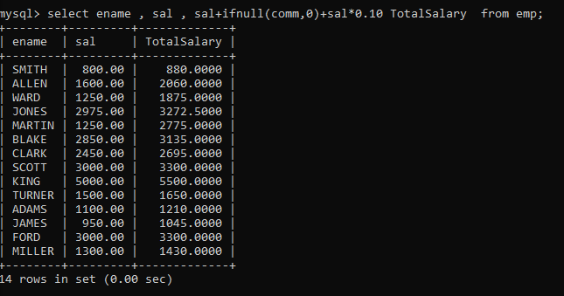

3. List the Name and job of the emp who have joined before 1 jan 1986 and whose

salary range is between 1200and 2500. Display the columns with user defined Column

headers.

mysql> select ename,job,hiredate from emp where hiredate < '1986-01-01' and sal between 1200 and 2500;

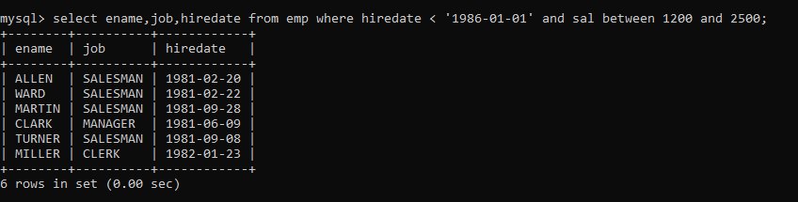

4. List the empno, name, and department number of the emp works under manager

with id 7698

mysql> select empno,ename,deptno from emp where empno=7698 group by empno;

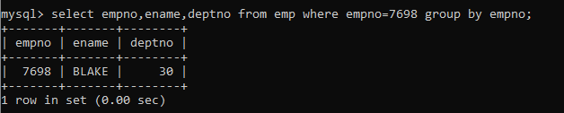

5. List the name, job, and salary of the emp who are working in departments 10 and

30.

mysql> select ename,job,sal,deptno from emp where deptno in (10,30) order by deptno;

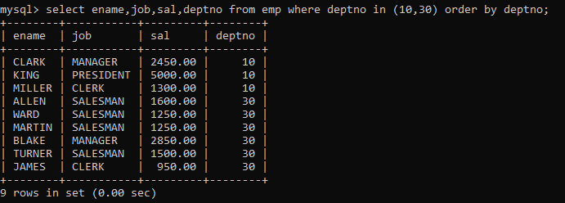

6. Display name concatenated with dept code separated by comma and space. Name

the column as ‘Emp info’.

mysql> select empno,ename,job,deptno,concat_ws(', ', ename,deptno) 'Emp Info' from emp;

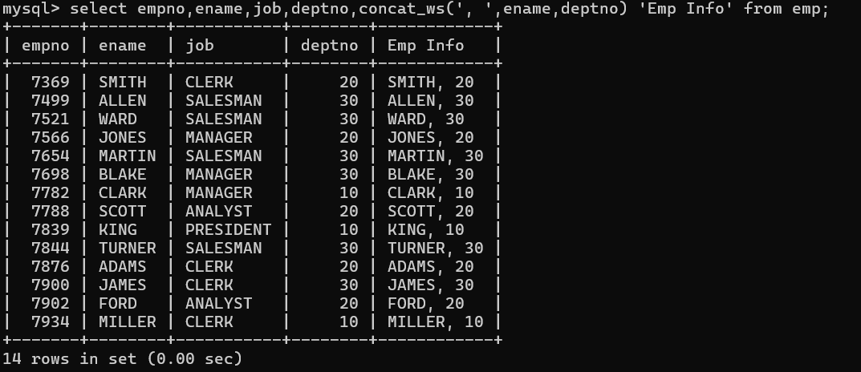

7. Display the emp details who do not have manager.

mysql> select * from emp where mgr is null;

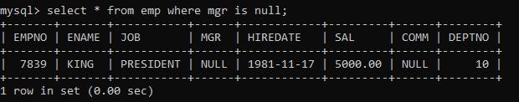

8. Write a query which will display name, department no and date of joining of all

employee who were joined January 1, 1981 and March 31, 1983. Sort it based on date of

joining (ascending).

mysql> select ename,deptno,hiredate from emp where hiredate between '1981-01-01' and '1983-03-31' order by hiredate;

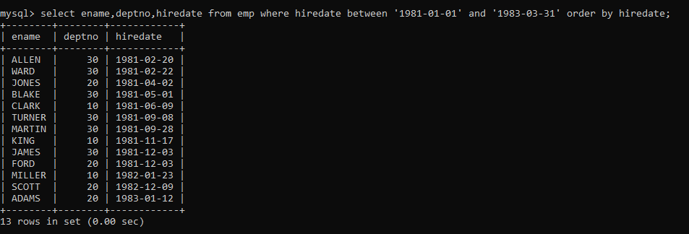

9. Display the employee details where the job contains word ‘AGE’ anywhere in the Job

mysql> select * from emp where job REGEXP '.*AGE.*';

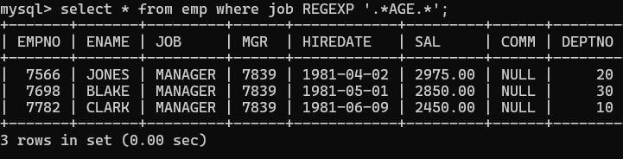

11. List the details of the employee , whose names start with ‘A’ and end with ‘S’ or whose names contains N as the second or third character, and ending with either ‘N’ or ‘S’

mysql> select * from emp where ename REGEXP '^A.*S|^.N?.*[NS]$';

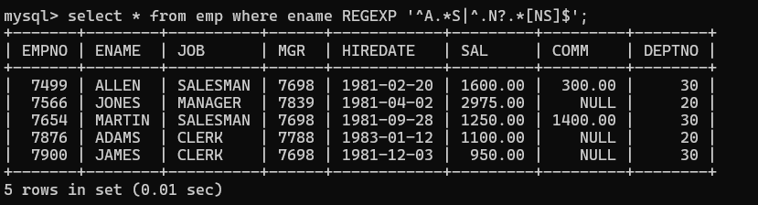

12. List the names of the emp having ‘_’ character in their name.

mysql> select * from emp where ename REGEXP '_' ;



Group functions

6. Display the Highest, Lowest, Total & Average salary of all employee. Label the columns Maximum, Minimum, Total and Average respectively for each Department. Also round the result to the nearest whole number.

mysql> select max(sal) Highest,min(sal) Minimum,sum(sal) Total,ceil(avg(sal)) Average from emp group by deptno ;

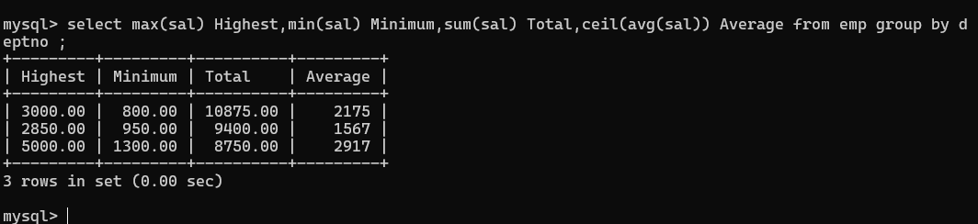

7. Display Department no and number of managers working in that department. Label the column as ‘Total Number of Managers’ for each department

mysql> select deptno,count(mgr) 'Total Number of Manager' from emp group by deptno having count(mgr)

-> order by deptno;

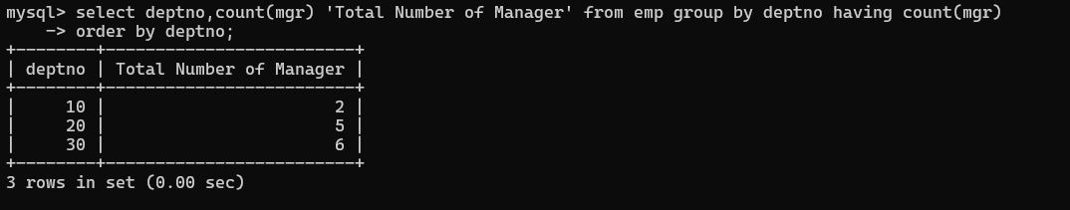

8. Get the Department number, and sum of Salary of all non managers where the sum is greater than 20000.

mysql> select deptno,ename,mgr,sum(sal) from emp where sal>20000 and mgr is null;



Single Row functions

1. To list all employees and their email, to generate email use 2 to 5 characters from ename Concat it with 2 to 4 characters in job and then concat it with ‘@mycompany.com’

mysql> select empno,ename,job,concat(substr(ename,1,4),substr(job,1,4),'@mycompany.com') 'E-mail' from emp;

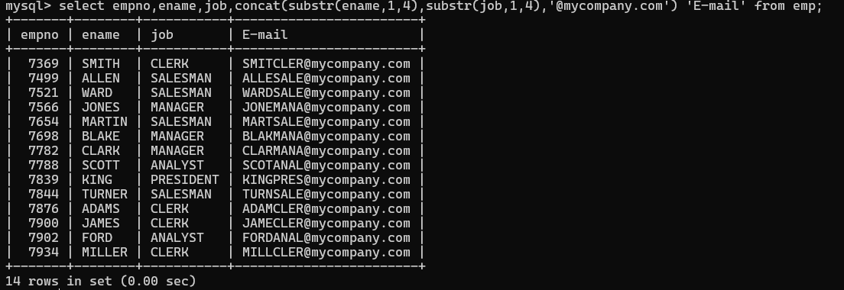

1. List all employees who joined in September.

mysql> select * from emp where Month(hiredate)=9;

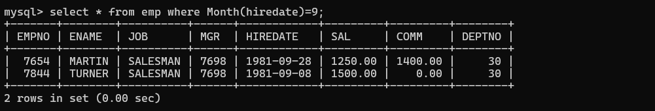

1. List the empno, name, and department number of the emp who have experience of 18 or more years and sort them based on their experience.

mysql> select empno,ename,deptno,floor(datediff(curdate(),hiredate)/365) Experience from em

p where floor(datediff(curdate(),hiredate)/365)>=18 order by datediff(curdate(),hiredate);

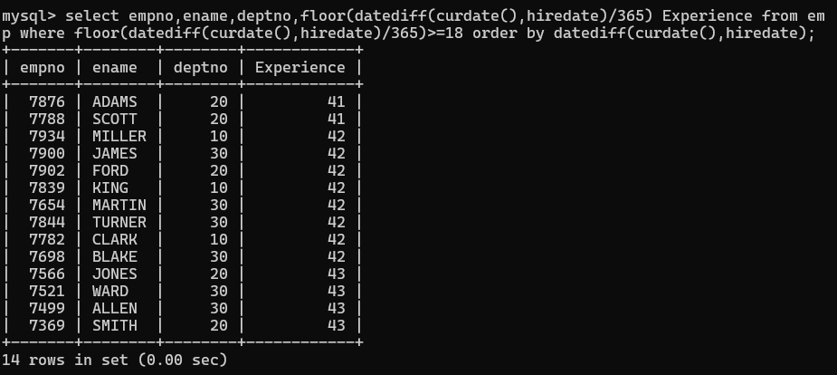

1. Display the employee details who joined on 3rd of any month or any year

mysql> select * from emp where day(hiredate)=3 ;

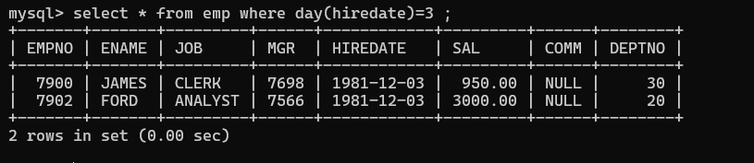

1. display all employees who joined between years 1981 to 1983.

mysql> select * from emp where year(hiredate) between 1981 and 1983;

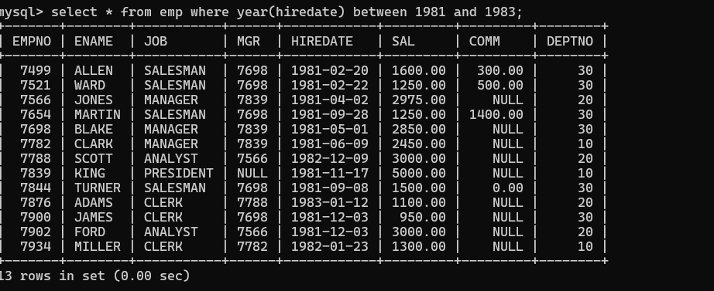

Assignment 1 – Suppliers

1. display all suppliers who statys in state either in california

or Texas or Arkansas

**Ans ->** mysql> select * from suppliers where state in ('California','Texas','Arkansas');

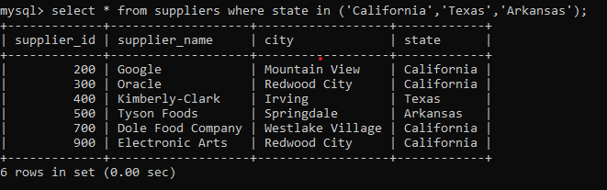

2. list all suppliers who does not stay in Springdale

**Ans ->** mysql> select * from suppliers where state!='Springdale';

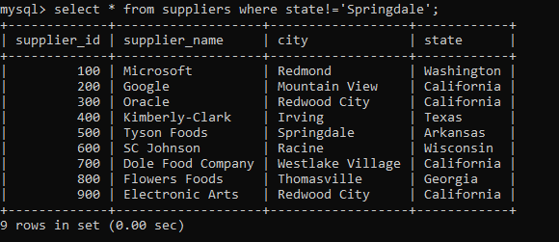

3. find orderid and customerid for orders place on date 18-feb-16

**Ans ->** mysql> select customer_id,order_id from orders where order_date ='2016-02-18';

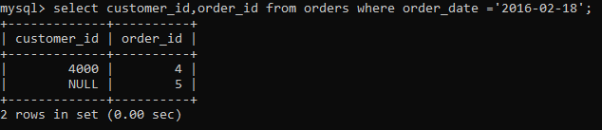

4. find orderid and customerid for orders place on feb 2016

**Ans ->** mysql> select customer_id,order_id,order_date from orders where order_date between '2016-02-01' and '2016-02-29';

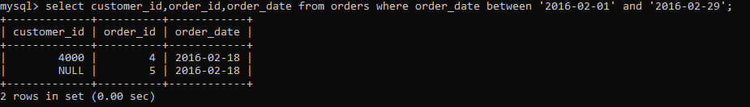

5. find all customers with name 'Reynolds', or Anderson

**Ans ->** mysql> select last_name from customers where last_name in ('Reynolds','Anderson');

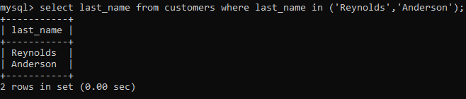

6. find all suppliers with supplierid >=200 and <=700

**Ans ->** mysql> select * from suppliers where supplier_id between 200 and 700;

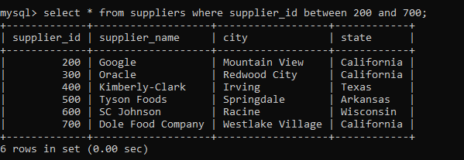

7. find all customers for whome favorite_website is not given

**Ans ->** mysql> select * from customers where favorite_website is null;

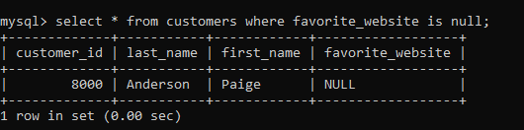

8. find all customers for whome favorite_website is given

**Ans ->** mysql> select * from customers where favorite_website is not null;

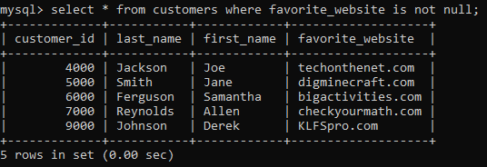

9. find all suppliers with supplierid not >=200 and not <=700

**Ans ->** mysql> select * from suppliers where supplier_id not between 200 and 700;

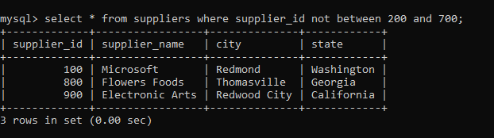

**ASSIGMENT 2**

**practice DQL statement**

Write SQL statement for the following

1. To find all managers with salary >1500

mysql> select * from emp where sal>1500;

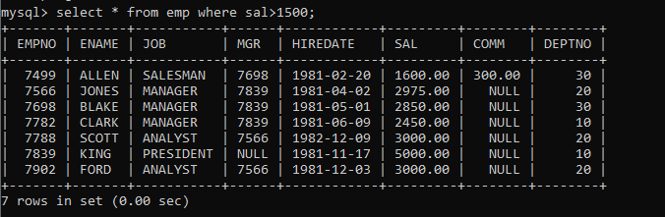

2. list all employees with sal >1200 and < 2000

mysql> select * from emp where sal between 1200 and 2000;

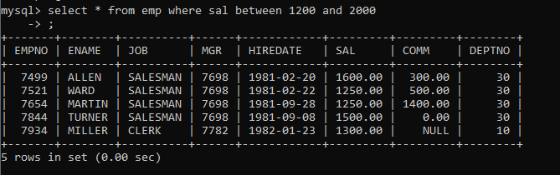

3. list all employees with sal is 1600 or sal is 800 or sal is 1900

mysql> select * from emp where sal in (1600,800,1900);

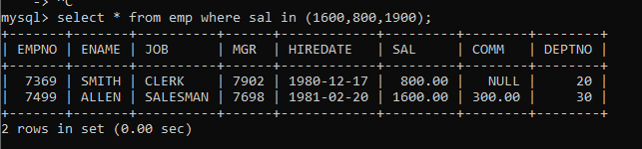

4. list all employees with R at second last position in name

mysql> select * from emp where ename REGEXP '^.*R.$';

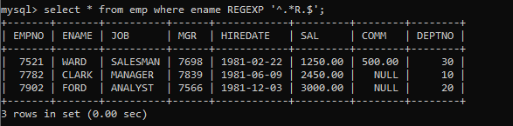

5. List all employees with name starts with A and ends with N

mysql> select * from emp where ename REGEXP '^A.*N$';

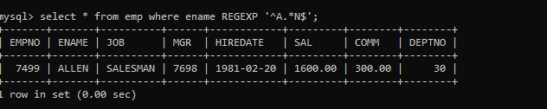

Q2. Solve following

1. list all employees with salary > 1250 and dept no=30

mysql> select * from emp where sal>1250 and deptno=30;

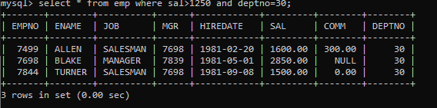

2. list all employees with salary >=1250 and <= 3000

mysql> select * from emp where sal between 1250 and 3000;

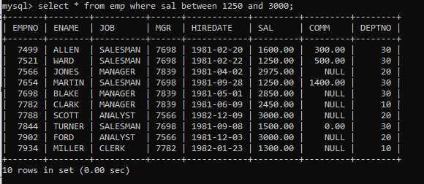

3. list all employees with salary >1250 and < 3000

mysql> select * from emp where sal >1250 and sal <3000;

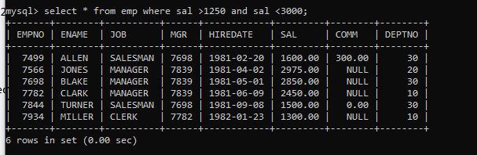

4. list all employees with salary either equal to 3000 or 1250 or 2500

mysql> select * from emp where sal in (3000,1250,2500);

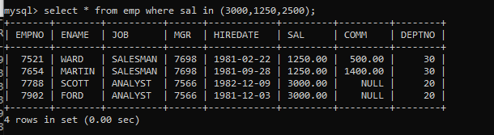

5. list all employee with name=SMITH

mysql> select * from emp where ename = 'SMITH';

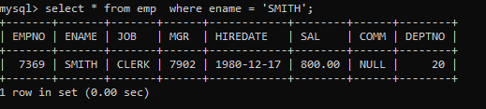

6. list all employees with name starting with S

mysql> select * from emp where ename REGEXP '^S';

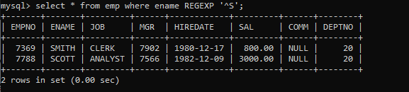

7. list all employees with name ending with S

mysql> select * from emp where ename REGEXP 'S$';

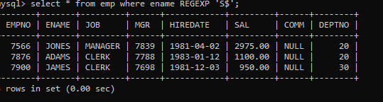

8. list all employees with name contains I at 2nd position

mysql> select * from emp where ename REGEXP '^.I' ;

mysql> select * from emp where ename like '_I%';

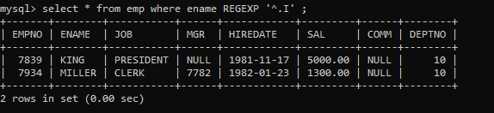

9. list all employees with name starts with A ends with N and somewhere in between L is there

mysql> select * from emp where ename REGEXP '^A.*L.*N$';

mysql> select * from emp where ename like 'A%L%N';

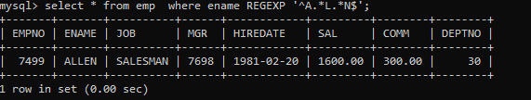

10. list all employees with name starts with A and B at 3 rd position and P at second last position

mysql> select * from emp where ename like 'A_B%P_';

mysql> select * from emp where ename REGEXP '^A.B.*P.$';

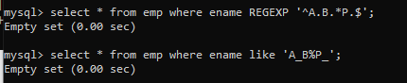

11. List all employees with name starts with either A or starts with S or starts with W

mysql> select * from emp where ename REGEXP '^[ASW]';

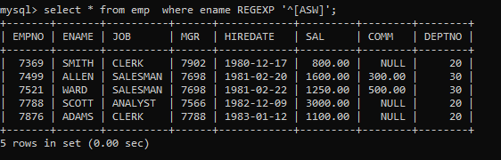

**practice Aggregate functions**

12. find max sal and min sal for each job

mysql> select job, min(sal) Minimum,max(sal) Maximum

-> from emp

-> group by job

-> ;

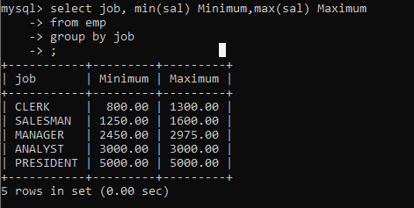

13. find how many employess have not received commission

mysql> select count(*) as 'Employee not recieved Comm'

-> from emp

-> where comm is null

-> ;

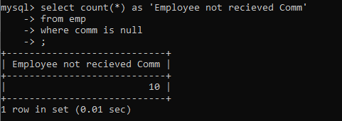

14. find sum of sal of all employees working in dept no 10

mysql> select deptno , sum(sal) as 'Sum of Sal of Dept no 10 '

-> from emp

-> where deptno =10

-> ;

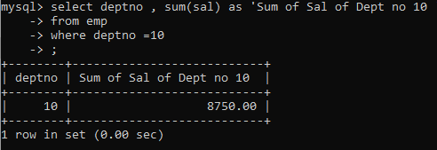

15. find maximum salary,average sal for each job in every department

mysql> select deptno,job,avg(sal),max(Sal)

-> from emp

-> group by deptno,job

-> order by deptno

-> ;

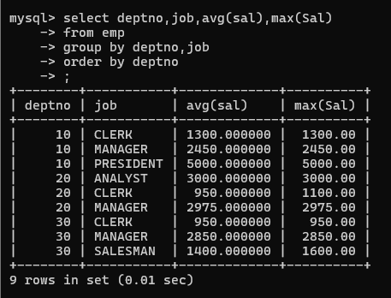

16. find max salary for every department if deptno is > 15 and arrange data in deptno order.

mysql> select deptno , max(sal)

-> from emp

-> where deptno > 15

-> group by deptno

-> order by deptno

-> ;

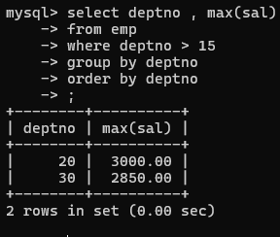

17. find sum salary for every department if sum is > 3000

mysql> select deptno , sum(sal)

-> from emp

-> group by deptno

-> having sum(sal) > 3000

-> ;

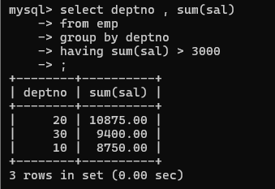

18. list all department which has minimum 5 employees

mysql> select deptno , count(*) from emp

-> group by deptno

-> having count(*)<=5;

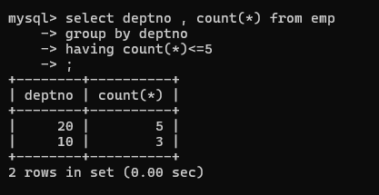

19. count how many employees earn salary more than 2000 in each job

mysql> select distinct job , sal , count(job) count_emp

-> from emp

-> where sal>2000

-> group by job

-> ;

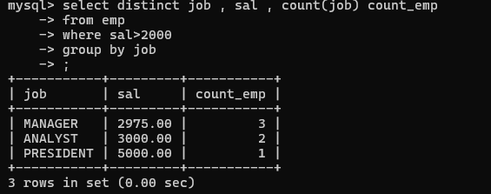

20. list all enames and jobs in small case letter

mysql> select lower(ename) , lower(job)

-> from emp

-> ;

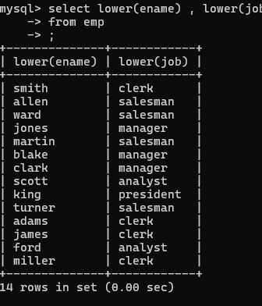

21. list all names and jobs so that the length of name should be 15 if it is smaller then add spaces to left

mysql> select lpad(ename,15,' ') ename,job

-> from emp

-> ;

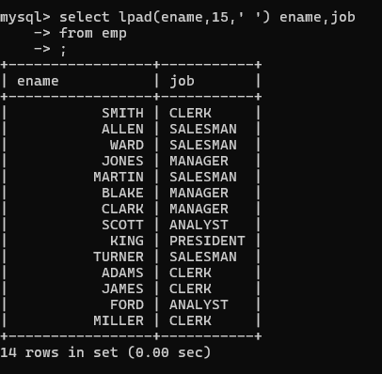

22. display min sal,max sal, average sal for all employees working under same manager

mysql> select mgr , format(min(sal),2) as MIN,format(avg(sal),2) as AVG,format(max(sal),2) as MAX

-> from emp

-> where mgr is not null

-> group by mgr

-> ;

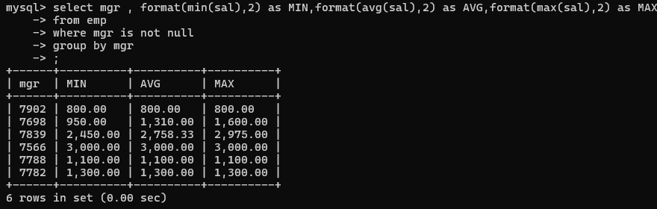

23. find sum of total earnings(sal+comm), average of sal+comm, for all employees who earn sal > 2000

and work in either dept no 10 or 20

mysql> select deptno , sum(sal+ifnull(comm,0)) Total,avg(sal+ifnull(comm,0)) Average

-> from emp

-> where sal >2000 and deptno in (10,20)

-> group by deptno

-> order by deptno

-> ;

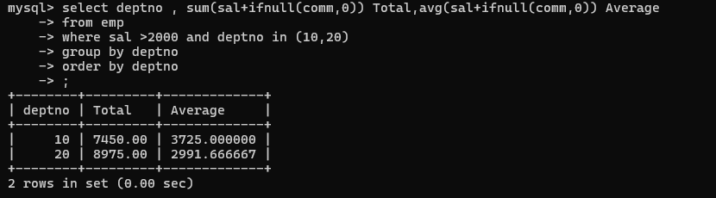

24. list all employees who joined in Aug 1980 and salary is >1500 and < 2500

mysql> select *

-> from emp

-> where hiredate between '1980-08-01' and '1980-08-31'

-> and

-> sal between 1500 and 2500

-> ;

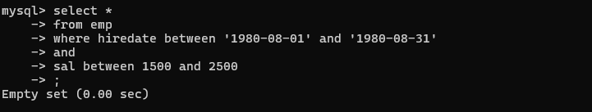

25. list all employees joined in either aug or may or dec

mysql> select *

-> from emp

-> where

-> month(hiredate) in (8,5,12)

-> ;

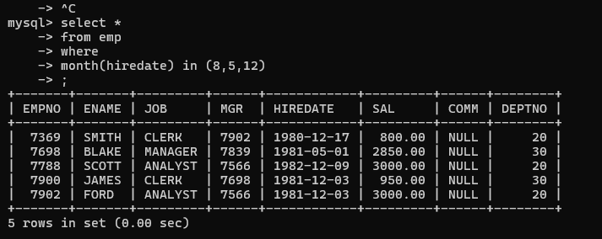

26. display name and hiredate in dd/mm/yy format for all employees whose job is clerk and they earn some commission

mysql> select job,ename,comm,date_format(hiredate,'%d/%m/%Y')

-> from emp

-> where job = 'Clerk' and comm is not null

-> ;

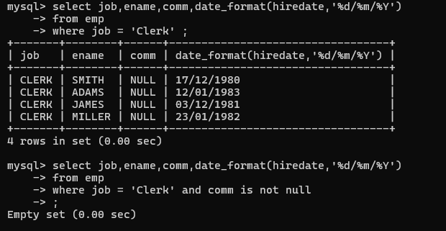

27. list empcode,empno,name and job for each employee. (note :empcode is 3 to 5 characters

from name and last 2 characters of job)

mysql> select empno,ename,concat(left(ename,3),right(job,2)) empcode

-> from emp

-> ;

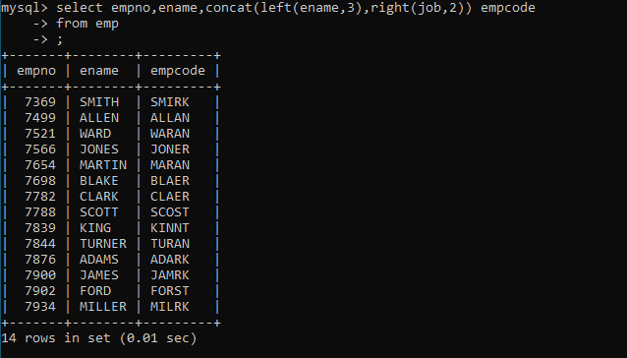

28. display thousand separator and $ symbol for commission if it is null then display it as 0 for all

employees whose name starts with A and ends with N

29. Display empid,name,sal,comm,remark Remark should base on following conditions

comm >= 600 "excellent Keep it up"

if it < 600 or not null "good"

otherwise "Need improvement"

mysql> select empno,ename,sal,comm, case when comm>=600 then 'Excellent Keep it Up'

-> when comm<600 then 'good'

-> else 'Need Improvement' end Remark

-> from emp

-> ;

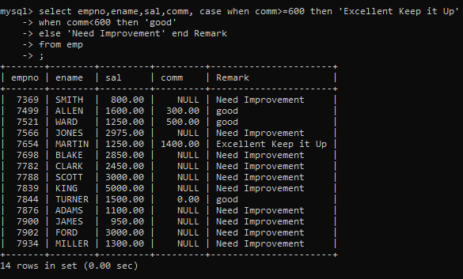

30. Display empid, name, deptno and department name by using following conditions.

dept 10 then "Hr"

if 20 then "Admin"

if 30 then "accounts"

otherwise purchase

mysql> select empno,ename,deptno,case when deptno=10 then 'Hr'

-> when deptno=20 then 'Admin'

-> when deptno = 30 then 'Accounts'

-> else 'purchase' end 'Department Name'

-> from emp

-> ;

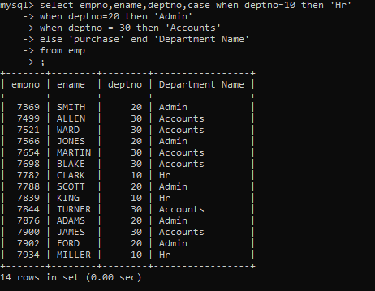

**\*) Date and Time functions**

1. Write a query to display the first day of the month (in datetime format) three months before the current month.

Sample current date : 2014-09-03

Expected result : 2014-06-01

mysql> select DATE_SUB(DATE_FORMAT(curdate(),'%Y/%m/01'),interval 3 month) as FirstDay;

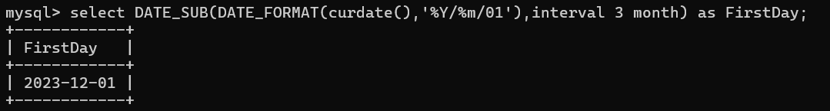

1. Write a query to display the last day of the month (in datetime format) three months before the current month.

mysql> select last_day(date_sub(curdate(),interval 3 month)) as LastDay;

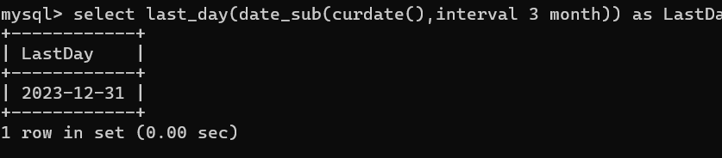

1. Write a query to get the distinct Mondays from hiredate in emp tables.

mysql> select distinct dayname(hiredate) , hiredate

-> from emp

-> where dayname(hiredate) like 'Monday'

-> ;

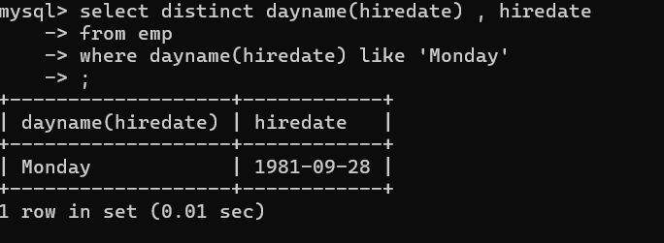

1. Write a query to get the first day of the current year.

mysql> select date_format(curdate(),'%Y-01-01') as FirstDayYear;

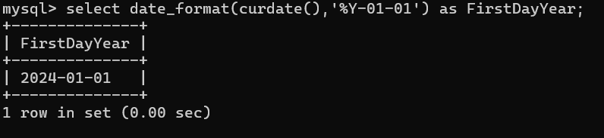

1. Write a query to get the last day of the current year.

mysql> select last_day(date_format(curdate(),'%Y-12-%d')) as LastDay;

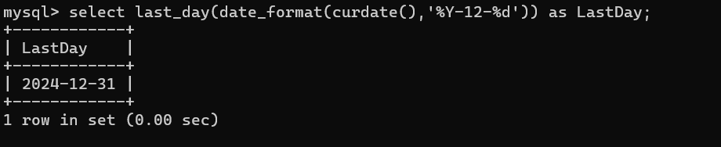

1. Write a query to calculate your age in year.

mysql> select floor(datediff(curdate(),'2001-04-04')/365) as myAge;

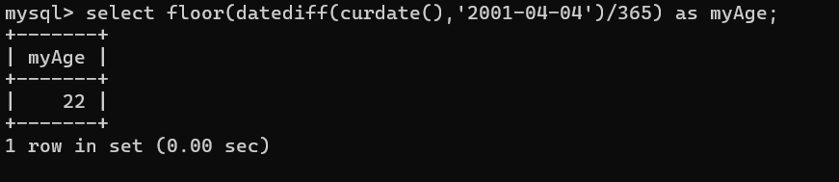

1. Write a query to get the current date in the following format. Sample date : 04-sep-2014 Output : September 4, 2014

mysql> select date_format(curdate(),'%M %d, %Y') as Format;

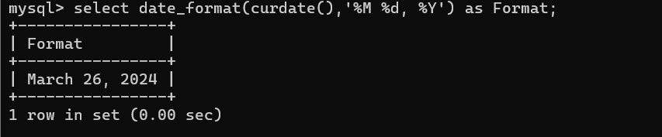

1. Write a query to get the current date in Thursday September 2014 format. Thursday September 2014

mysql> select date_format(curdate(),'%W %M %Y ') as Date ;

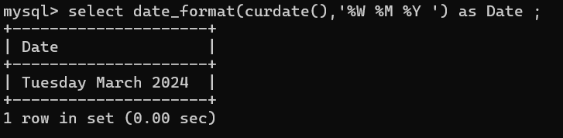

1. Write a query to extract the year from the current date.

mysql> select curdate() as Date ,extract(year from curdate()) as Year

-> ;

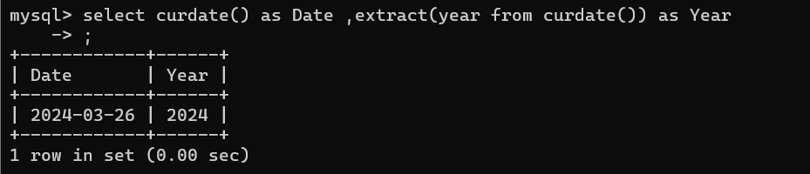

1. Write a query to get the first name and hire date from employees table where hire date between '1987-06-01' and '1987-07-30'

mysql> select ename , hiredate

-> from emp

-> where hiredate between '1987-06-01' and '1987-07-30'

-> ;

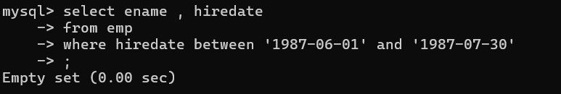

11. Write a query to display the current date in the following format. Sample output: Thursday 4th September 2014 00:00:00

mysql> select date_format(now(),'%W %d %M %Y %h:%i:%s ') as 'Current Date and Time ' ;

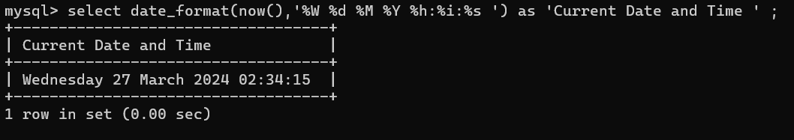

12. Write a query to display the current date in the following format. Sample output: 05/09/2014

mysql> select date_format(curdate(),'%d/%m/%Y') as 'Today\'s Date';

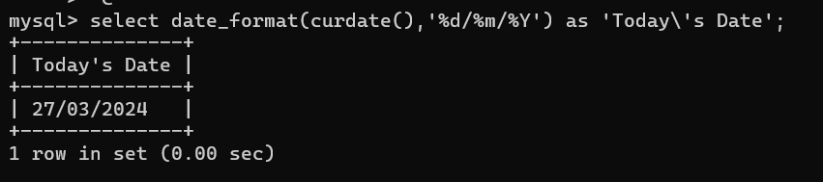

13. Write a query to display the current date in the following format. Sample output: 12:00 AM Sep 5, 2014

mysql> select date_format(now(),'%h:%i %p %b %d , %Y') as 'Sample Output';

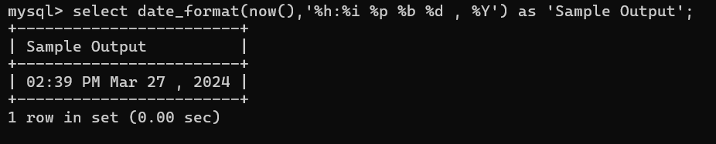

14. Write a query to get the employees who joined in the month of June.

mysql> select * from emp where monthname(hiredate)='June' ;

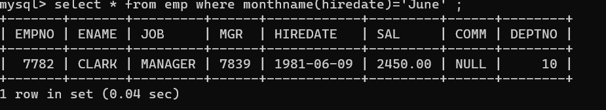

15. Write a query to get the years in which more than 10 employees joined.

mysql> select year(hiredate) as 'Year',count(year(hiredate)) as 'Counting Year'

-> from emp

-> group by year(hiredate)

-> having count(year(hiredate))>=10

-> ;

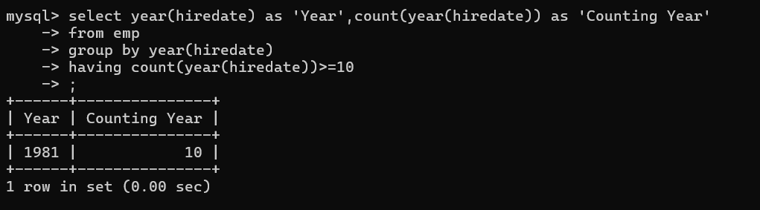

16. Write a query to get first name of employees who joined in 1987.

mysql> select ename ,hiredate

-> from emp

-> where hiredate between '1987-01-01' and '1987-12-31'

-> order by hiredate

-> limit 1

-> ;

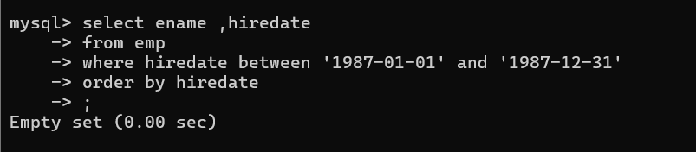

17. Write a query to get employees whose experience is more than 5 years.

mysql> select *

-> from emp

-> where datediff(curdate(),hiredate)/365 > 5

-> ;

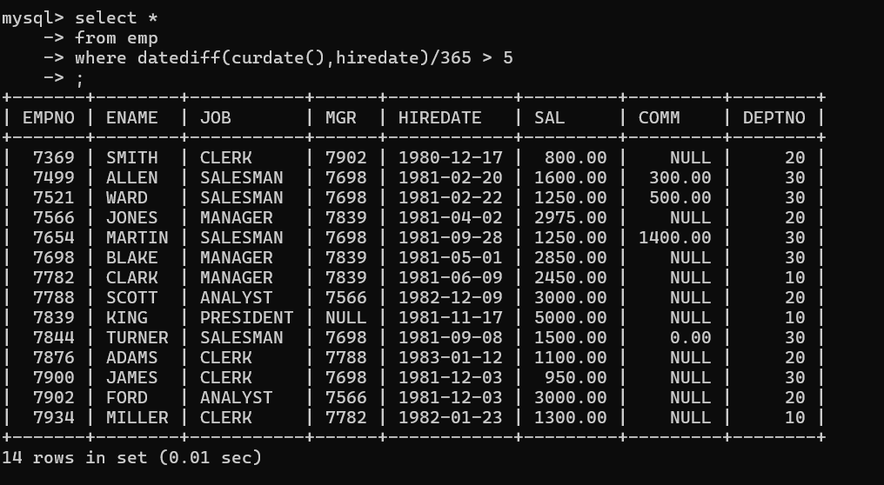

ASSIGNMENT 3

1. 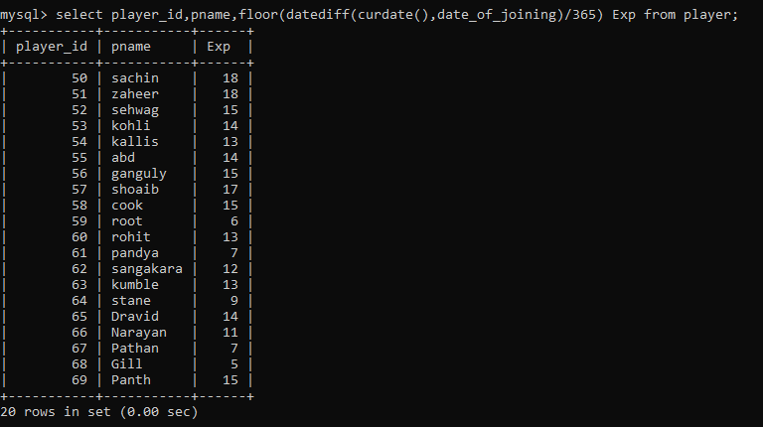
2. 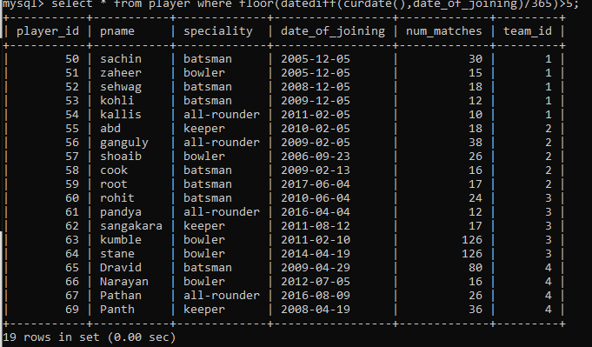
3. 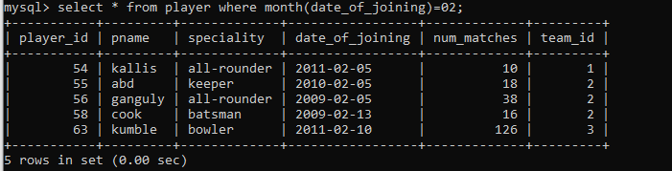
4. 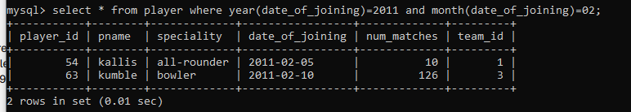
5. 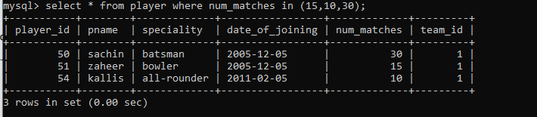
6. 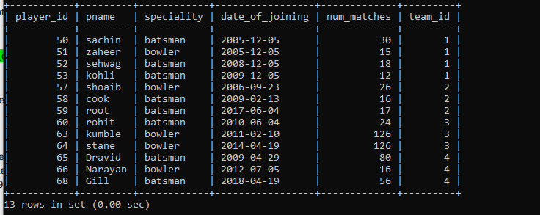
7. 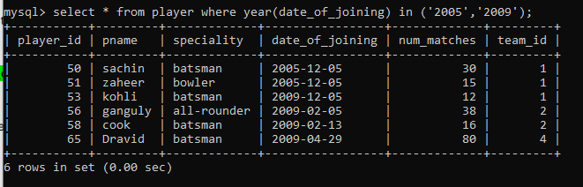

Q2.

1. 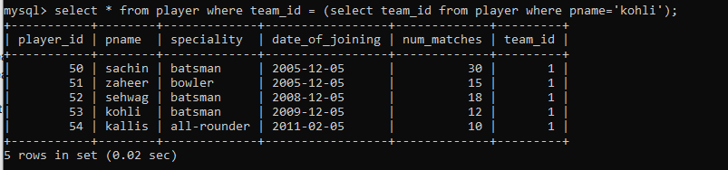
2. 2. 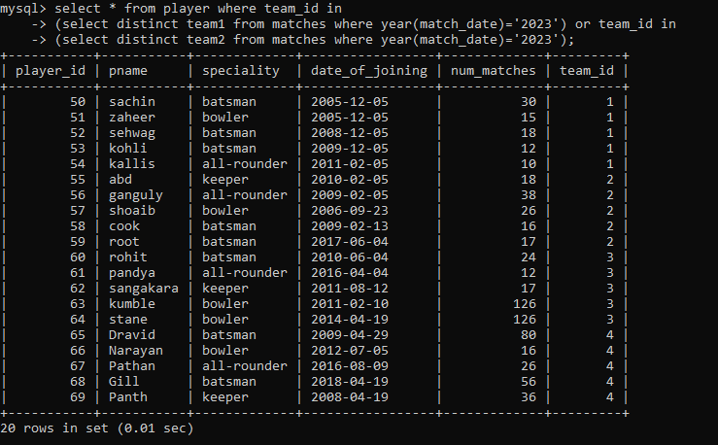
3. 3. 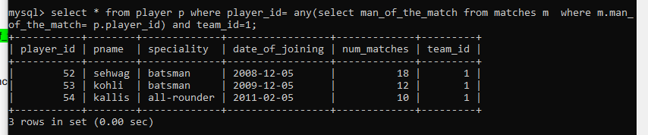
4. 4. 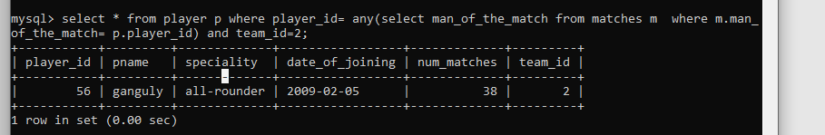
5. 5. 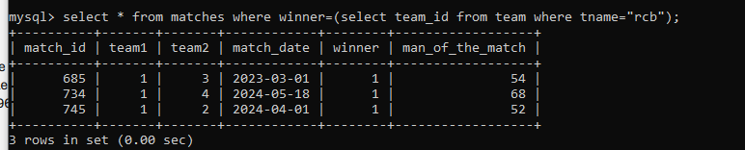
6. 6. 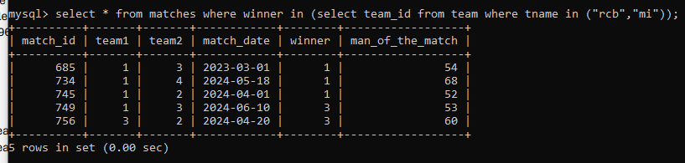
7. 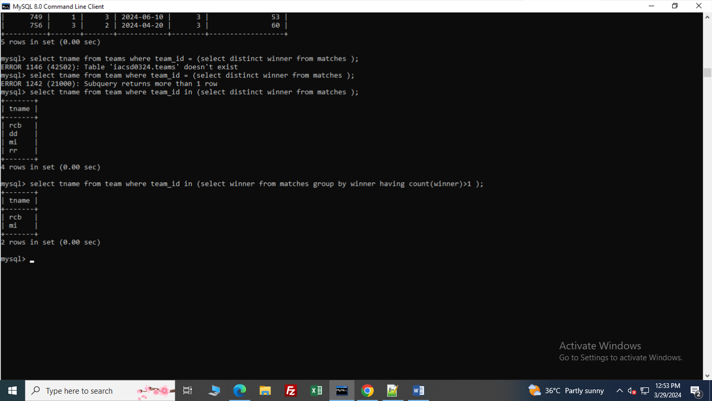

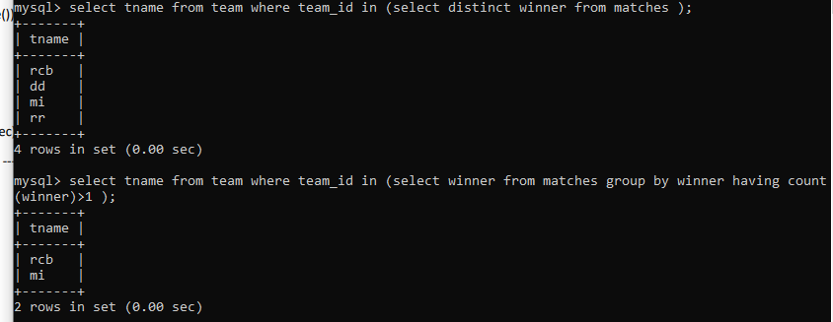

ASSIGNMENT 4

1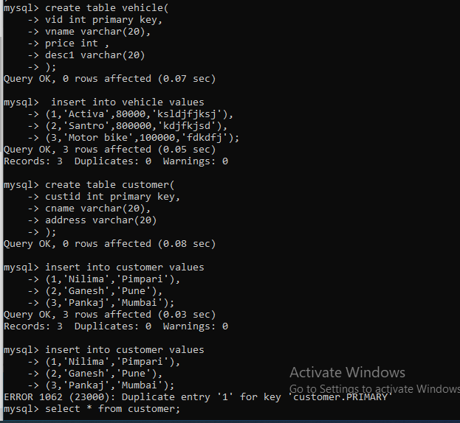

1.

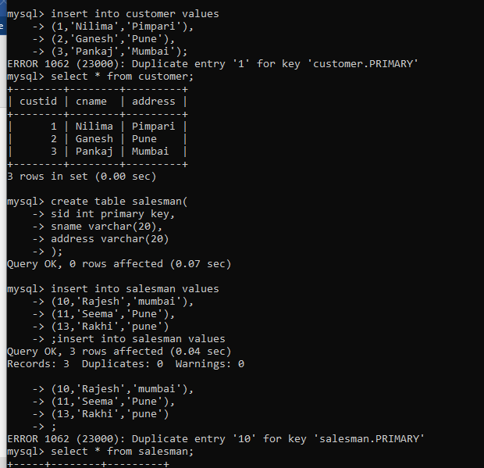

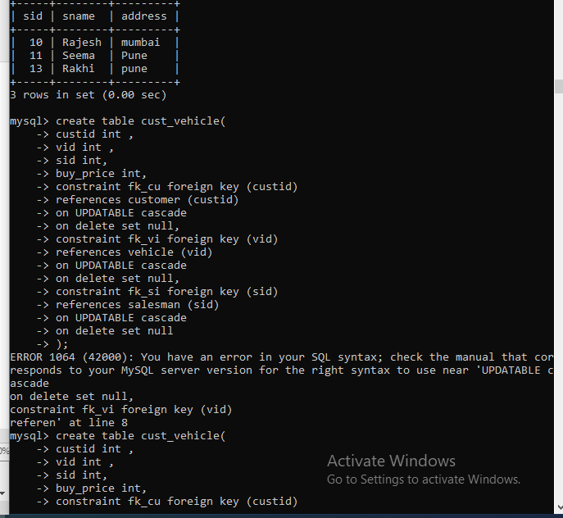

2.

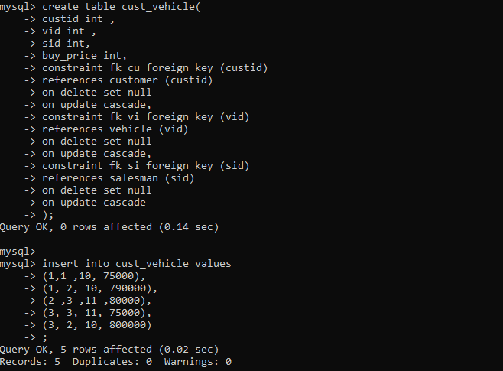

3. 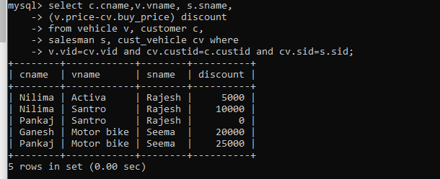

4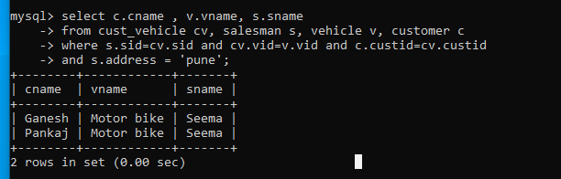

6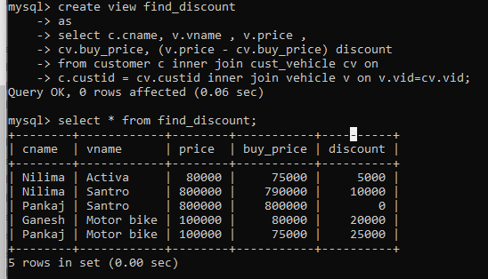

8.0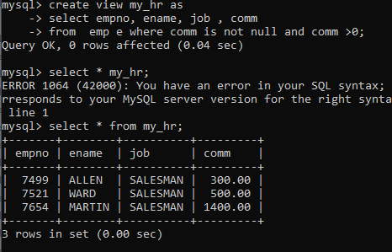

9. 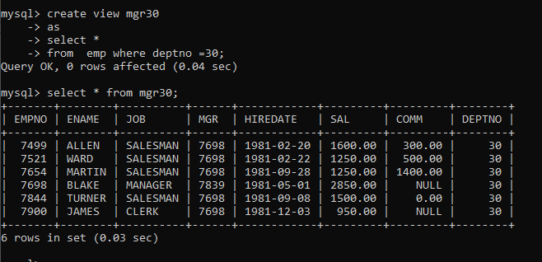

10. 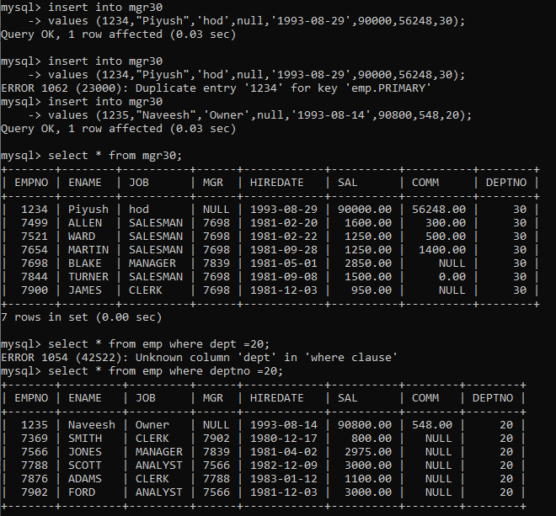

11.

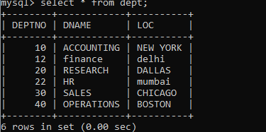

12